(Approx. 313 words)

What’s New
Energi Charger Station
by George Harding Treasurer, Tucson Computer Society
www.aztcs.org
georgehardingsbd (at) earthlink.net

Here’s a handy charger for you. It can charge five devices at once! It senses your device capability for charging and adapts to it. It works with small and large devices. It has a removable external charger.

Tylt offers this product to their long line of innovative tools. I have an external charger for my iPhone that is both a case and a charger. The case provides the usual protective features. The charger fits around the case and connects by the built-in lightning connector. Pretty slick!

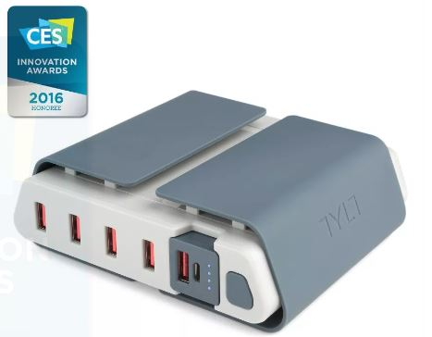
Energi is another example of innovative engineering for consumer devices. The main unit connects to a standard wall outlet and provides five USB slots for charging your devices. Each is capable of charging either a smartphone or similar device or a tablet.
Each slot has what the Company calls SmartDetect technology to provide maximum rapid charging. That means both fast charging and no over-charging. The latter benefit is important in today’s environment of concern for fires caused by over-charging.
The four standard USB slots provide 2.4 amps of power while the fifth slot can provide 3.5 amps for even faster charging.
A unique feature of this charging station is the removable battery pack (the fifth slot). It can be easily removed and carried in a pocket or purse for on-the-spot use. No need to find a wall socket when you run out of charge.
The fins on the top of the unit can be used to organize your cables whether because there are too many or they are too long.
The unit comes with a start-up guide which is very short, with diagrams as well as text in several languages.
The unit comes with a one year warranty after you register your unit.
Energi Charging Station by TYLT
Price $80
www.tylt.com/charging-station

